

**WEB TECHNOLOGIES**

**ASSIGNMENT 03**

**SUBMITTED BY:**

**FAIZA**

**ROLL NO:**

**22201003- 015**

**DEPARTMENT:**

**INFORMATION TECHNOLOGY**

**SEMESTER:**

**BS (IT) 6th**

**SUBMITTED TO:**

**MAAM SANA**

**FIRST PAGE**

**Give name, student_id and email:**

<html>

    <head>

        <title>page1</title>

    </head>

    <body>

<div class="container">

    <h2 id="form-title">Personal Information</h2>

    <div id="login" class ="form-container">

        <form method='GET' action='page2.php'>

        <label>name</label><input type="text" name ="name"><br>

        <label>email</label><input type="email" name ="email"><br>

        <label>student_id</label><input type="id" name ="id"><br>

        <input type="submit" name="submit" value="proceed">

        </form>

    </div>

</div>

    </body>

</html>

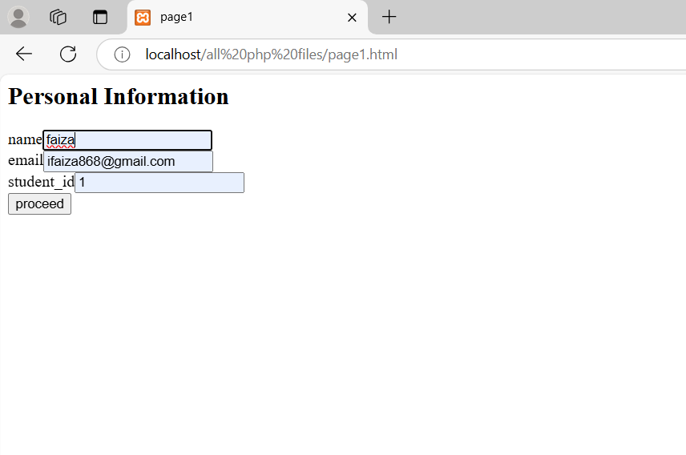

**Page 2**

**Enter marks of every subject if the student is valid:**

<html>

    <head>

</head>

<body>

    <div class = "container">

<?php

if($_GET ["email"] == "ifaiza868@gmail.com" && $_GET ["id"] == "1")

{

   echo "<p>".$_GET["name"]."</p>";

   echo"<p> Marks:" ."<p>";                 }

 else {

    header('location:page1.html');}

    if($_GET ["email"] == "ifaiza868@gmail.com" && $_GET ["id"] == "1") {

    $subject=["web","MAD","it_infra","DM"];

   foreach ($subject as $marks => $subject);

}

?>

<!-- HTML Form -->

<form method="post" action="page3.php">

    <label for="web">WEB:</label>

    <input type="number" id="web" name="web" ><br><br>

    <label for="MAD">MAD:</label>

    <input type="number" id="MAD" name="MAD" ><br><br>

    <label for="it_infra">It_infrastructure:</label>

    <input type="number" id="it_infra" name="it_infra" ><br><br>

    <label for="DM">DM:</label>

    <input type="number" id="DM" name="DM" ><br><br>

    <button onclick ="show()"> </button>

</form>

</div>

</body>

</html>

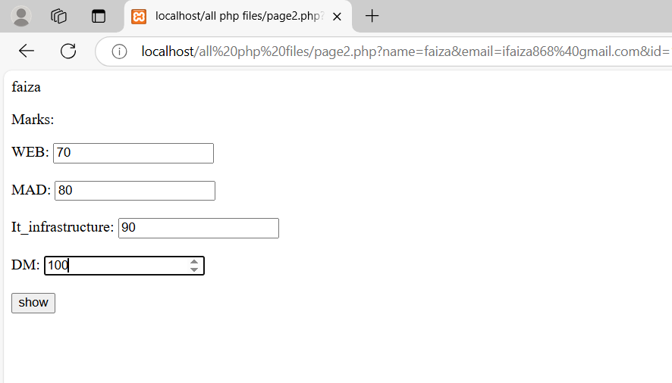

**Page 3**

**Give grades to all subjects:**